**PIKACHU PARA – GAME DEVELOPMENT**

**A MINI PROJECT REPORT**

***Submitted by***

|  |  |
| --- | --- |
| **PAVITHRA DEVI V** | **212219040104** |
| **RAGA RANJINI R** | **212219040115** |

***in partial fulfillment for the award of the degree***

***of***

**BACHELOR OF ENGINEERING**

**in**

**COMPUTER SCIENCE AND ENGINEERING**



## SAVEETHA ENGINEERING COLLEGE

**ANNA UNIVERSITY :: CHENNAI- 600 025**

**DECEMBER 2021**

**ANNA UNIVERSITY, CHENNAI**

**BONAFIDE CERTIFICATE**

Certified that this mini project report **“PIKACHU PARA – GAME DEVELOPMENT”** is the bonafide work of **PAVITHRA DEVI V (212219040104) and RAGA RANJINI R (212219040115)** who carried out the mini project work under my supervision.

**SIGNATURE SIGNATURE**

**Dr. RAVINDHAR NV,M.E.,Ph.D. , Dr.G.NAGAPPAN,M.E.,Ph.D.,**

Professor Professor

**SUPERVISOR HEAD OF THE DEPARTMENT**

Dept of Computer Science and Dept of Computer Science and

Engineering, Engineering,

Saveetha Engineering College, Saveetha Engineering College,

Thandalam , Chennai - 602105. Thandalam , Chennai - 602105.

DATE OF THE VIVA VOCE EXAMINATION: ……………………..

**INTERNAL EXAMINER EXTERNAL EXAMINER**

**ACKNOWLEDGEMENT**

We express our deep sense of gratitude to our honourable and beloved Founder President Dr. N. M. Veeraiyan, our President Dr. Saveetha Rajesh, our Director Dr. S. Rajesh and other management members for providing the infrastructure needed.

We express our wholehearted gratitude to our Principal, Dr. N. Duraipandian, for his wholehearted encouragement in completing this mini project.

We convey our thanks to Dr. G. Nagappan, Professor and Head of the Department of Computer Science and Engineering, Saveetha Engineering College, for his kind support and for providing necessary facilities to carry out the mini project work.

We would like to express our sincere thanks and deep sense of gratitude to our Supervisor and Project Coordinator Dr. Ravindhar NV , Professor, Department of Computer Science and Engineering, Saveetha Engineering College for his valuable guidance, suggestions and constant encouragement that paved the way for the successful completion of the mini project work and for providing us necessary support and details at the right time and during the progressive reviews.

We owe our thanks to all the members of our college, faculty, staff and technicians for their kind and valuable cooperation during the course of the mini project. We are pleased to acknowledge our sincere thanks to our beloved parents, friends and well-wishers who encouraged us to complete this mini project successfully.

**Table of Contents**

|  |  |  |
| --- | --- | --- |
| **Chapter Number** | **Title** | **Page Number** |
| **1** | **INTRODUCTION** | **8** |  |
|  | 1.1 Overview of the project | 8 |  |
|  | 1.2 Scope and Objective | 9 |  |
| **2** | **LITERATURE SURVEY** | **11** |  |
|  | 2.1 Introduction | 11 |  |
|  | 2.2 Literature Survey | 12 |  |
| **3** | **SYSTEM DESIGN** | **13** |  |
|  | 3.1 Introduction | 13 |  |
|  | 3.2 Existing System | 14 |  |
|  | 3.3 Proposed System | 14 |  |
|  | 3.4 Algorithm | 15 |  |
|  | 3.5 System Architecture Diagram | 15 |  |
|  | 3.6 Data Flow diagram  3.7 System Requirements 17 | 16 |
|  |  |  |
| **4** | **IMPLEMENTATION &ANALYSIS** | **17** |
|  | 4.1 Module Description | 17 |
|  | 4.2 Implementation | 18 |

4.3 Feasibility study 22

4.4 Result 23

4.5 System design and Testing 23

4.5.1 System design 23

4.5.2 Performance Testing 23

|  |  |  |
| --- | --- | --- |
| **5 CONCLUSION** |  |  |

5.1 Conclusion 24

5.2 Future Enhancement 24

**Appendix A - Software Description 25**

**Appendix B - Sample coding 25**

**Appendix C - Output 26**

**ABSTRACT**

Digital games have become a ubiquitous part of our society. Developing games bring our vision to life with the latest technological innovations and convenient tools . Today's most played games are shooting games like Player Unknown's Battle Grounds (PUBG) , Garena free fire , call of duty and so on . These games influence are not just over adults , there are many kids under the age of 10 addicted to these kind of games .

The main objective of our project is to develop a simple shooting game which can be used by kids for having fun . Pikachu PaRa is a real world video game built using Python with the help of Pygame . Player gets portrayed as a Pikachu with a shooting gun who is set to save his friends who are all in freeze mode , from the Antagonist group . Pikachu need to shoot the antagonist members before they reach the Pikachu's friends. Every time pikachu fails , the health bar (of friends) decreases ,that is , it turns red .After game time , accuracy level of the player gets displayed and compared with best accuracy rate till time . Data handling comes into play to store the accuracy rate of the player. Suitable background , graphics and sound effects were included for the game.

At the end of the project , We had a clear view on how to import required modules and resources for graphics and sound effects , and performing actions like movement and rotation using mouse and key events in pygame.

**CHAPTER 1**

**INTRODUCTION**

## **OVERVIEW OF THE PROJECT:**

Game development is the procedure of creating video games which involves working on some platform/software to develop the game.

Game development tools are specialized software solutions which allow and facilitate the development of a video game easier. In developing a game, the team of developers may need animation software to design a player, or trees, or any other object being used in the game; or a coder may need Visual Studio or Mono Develop editor to inject specific code to move a game object, all these tools come under Game development tools.

Digital games are a complex, multi modal art form which combines a variety of media and technologies and,as such,requires a diverse range of skills and competences to create. This complexity also means making games is a time-consuming process,most often undertaken in teams. The integration of various domains including programming.visual art and game design places great importance on interpersonal skills such as communication , management and leadership.

Besides of an abundant appearance of games in young students life,game development technology has matured and became more advanced than before.Based on various existing game development software,the whole duty of game development process can be divided into several domains and roles such as game programmers,3D model creators,game designers,musicians,animators,and play writers.Under this situation,some web resources and game engines can simplify the game development process.

## **1.2 SCOPE AND OBJECTIVE**

## **SCOPE:**

New game development trends emerge every year. And technology advances, bringing opportunities for game development studios to innovate.

There’s so much for game development studios to consider if they want to produce their next hit game.

The top four game development trends are all growing opportunities in the industry:

* AR/VR
* eSports
* 5G
* Inclusivity

It is forecasted that the gaming industry will generate great opportunities for game developers over the next two years. The gaming industry has grown its presence over various platforms – mobile, console, PC, online gaming and the industry is growing really fast along with the presence on all these platforms.

Increase in the use of internet and the consumption of digital content over various devices, are some of the reasons that would give significant growth to the gaming industry in India.

We can say that , Game development is a demanding career in today's modern world. With the wide access to the internet has created a humongous demand for online games and with the advent of technology, this industry is growing at fast pace. So a plethora of career options is available for aspirants from artists to musicians to sound engineers to programmers in this field.

## **OBJECTIVE:**

Studies of children exposed to violent media have shown that they may become numb to violence, imitate the violence, and show more aggressive behavior. Younger children and those with emotional, behavioral or learning problems may be more influenced by violent images.

In moderation, playing age-appropriate games can be enjoyable and healthy. Some video games may promote learning, problem solving and help with the development of fine motor skills and coordination. However, there are concerns about the effect of violent games like PUBG on young people (kids) who play these games excessively.

Thus , our problem is to develop an interesting game for young people with no violence . This game is a single player game allowing the user to beat their own best accuracy rate . So in this game , violence or violence creating objects are completely neglected .

**CHAPTER 2**

# **LITERATURE SURVEY**

## 

## **2.1 INTRODUCTION:**

Literature review is a text of a scholarly paper, which includes the current knowledge including substantive findings, as well as theoretical and methodological contributions to a particular topic. Literature reviews are secondary sources, and do not report new or original experimental work. Most often associated with academic-oriented literature, such reviews are found in academic journals, and are not to be confused with book reviews that may also appear in the same publication.

Literature reviews are a basis for research in nearly every academic field.

A literature survey provides a quick summary/overview of recent research in a topic. Sometimes it is also called a Tutorial.

A literature survey does not present new results, but provides a quick summary to the existing state of the art on a subject.

A literature survey represents a study of previously existing material on the topic of the report. This includes -

1. Existing theories about the topic which are accepted universally.

2. Books written on the topic, both generic and specific.

3. Research done in the field usually in the order of oldest to latest.

4. Challenges being faced and ongoing work, if available.

**2.2 LITERATURE SURVEY**

**TITLE 1 : Game programming patterns**

**AUTHOR : Robert Nystrom**

The design patterns revisited section of this book covers many of the patterns from design patterns, but with an emphasis on how they can be applied to game programming.

The measure of a design is how easily it accommodate changes . With no changes, it’s a runner who never leaves the starting line.

In this book, the author discussed that **the key goal of software architecture : minimize the amount of knowledge you need to have in-cranium before you can make progress.**

**DESIGN PATTERNS REVISITED:**

* Command
* Flyweight
* Observer
* Prototype
* Singleton
* State

**TITLE 2** : **Beginning Game Development with Python and Pygame**

**AUTHOR** : **Will McGugan**

In this book, the basics of python language has been fully covered with many sample programs. The author pointed that “Any game needs to make decision based on information it either has been given or has calculated.If a laser blast hits the player’s hover tank,the game has to decide if enough damage has been done to destroy it and display an explosion animation if it has. This is just an example of a whole host of decisions a computer game has to make in order to convince that it is more than just a dumb machine. So please put on your Spock ears and we will cover logic.

The later part of the book explained how to work with python using pygame to develop a game.

**CHAPTER 3**

**SYSTEM DESIGN**

**3.1 INTRODUCTION**

System design is the process of defining the components, modules, interfaces, and data for a system to satisfy specified requirements. System development is the process of creating or altering systems, along with the processes, practices, models, and methodologies used to develop them.

Core activities in system design and development include developing system-level technical requirements and top-level system designs and assessing the design's ability to meet the system requirements.

System-level technical requirements describe the users' needs, and provide information for the finished system to meet legal restrictions, adhere to regulations, and interoperate or integrate effectively with other systems.

System-level technical requirements are a critical precursor to and foundation of system design and development. A top-level system design is generally under the stewardship of the government team and represents the government team's independent projection of the way a system could be implemented to meet requirements with acceptable risk. The primary reason for developing a top-level system design is to provide a technical foundation for planning the program. A top-level system design developed early in an acquisition program can be used to assess system feasibility and provide some assurance that the implemented design will satisfy system requirements.

**3.2 EXISTING SYSTEM**

All games depend on technology. Moreover, the technologies used in games are so advanced that game companies are the leaders in graphical computation.

Although designing is a common practice in game projects, mainly by using a design document or game bible, many reports claim that there are problems in this phase.

Some projects were characterized by the great number of defects found in a development phase.

**Disadvantages**

* High Cost of Development
* Diminished Value Over Time
* Games That Are Only Poorly Masked Quizzes

**3.3 PROPOSED SYSTEM**

To build a shooting desktop game with sound effects in python language using Pygame module .

Using "Data handling" concept , accuracy rates gets stored every time the game is played and best accuracy rate gets displayed as a result .

**3.4 ALGORITHM**

**step 1** : A window pops up with two buttons namely , ' start ' and ' quit '.

**step 2** : When ' start ' button is pressed , the game starts and user can play . Else , the window gets closed .

**step 3** : 'W,A,S,D' keys for movement and mouse events gets tracked for rotation of the player .

**step 4** : If pikachu misses out to shoot the antagonist member and it reaches pikachu's friends zone , then the health bar decreases .

**step 5** : At the end of game time , If the health bar has something green then the player win else the player lost .

**step 6** : If player has won , then the accuracy rate will be displayed and compared with best accuracy rate till time .

**3.5 SYSTEM ARCHITECTURE DIAGRAM**

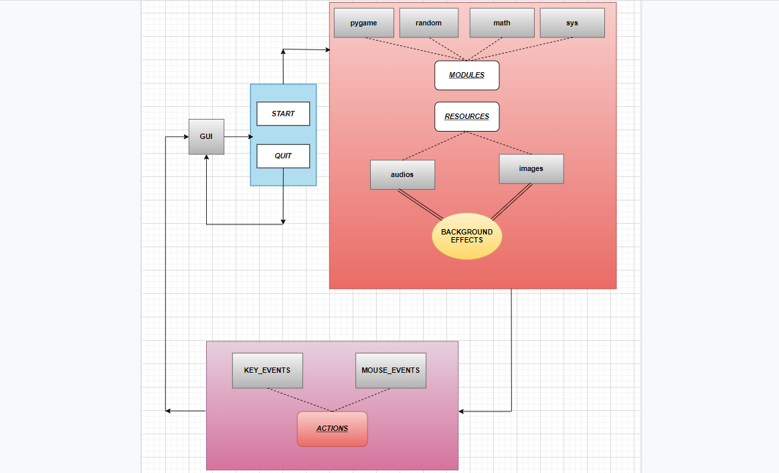

**3.6 DATA FLOW DIAGRAM**

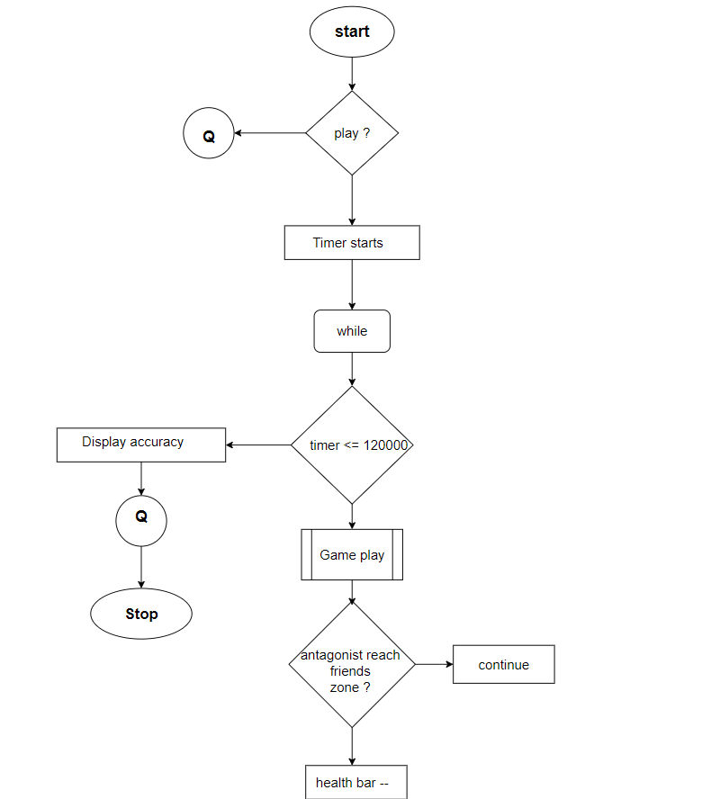

**3.7 SYSTEM REQUIREMENTS**

**Hardware & Software Requirements :**

* Processor : Intel(R) Core(TM) i5-8265U CPU @ 1.60GHz 1.80 GHz
* System Type : 64-bit operating system, x64-based processor
* Windows : Windows 10 Home Single Language
* OS build : 19042.1237
* Python IDLE - version 3.9.0
* Pygame library

**CHAPTER 4**

**IMPLEMENTATION AND ANALYSIS**

**4.1 MODULE DESCRIPTION**

**List of Modules :**

* pygame
* math
* random
* sys

**Pygame module :**

The pygame library is an open-source module for the Python Programming Language specifically intended to help you make games and other multimedia applications. Pygame can run across many platforms and operating systems.

**Math module :**

Math module is defined as the most famous mathematical functions, which includes trigonometric functions, representation functions, logarithmic functions, etc. Furthermore, It also defines two mathematical constants, i.e., Pie And Euler Number, etc.

**Random module :**

Python Random module is an in-built module of Python which is used to generate random numbers. This module can be used to perform random actions such as generating random numbers, print random a value for a list or string, etc

**Sys module :**

The sys module in Python provides various functions and variables that are used to manipulate different parts of the Python runtime environment . It allows operating on the interpreter as it provides access to the variables and functions that interact strongly with the interpreter.

**4.2 IMPLEMENTATION**

**Step 1: import libraries needed for the game development .**

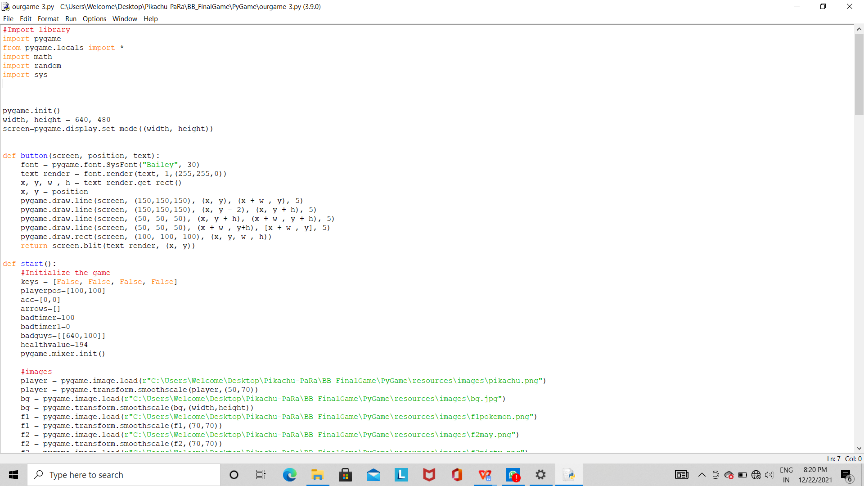

**Step 2: create a window with two buttons .**

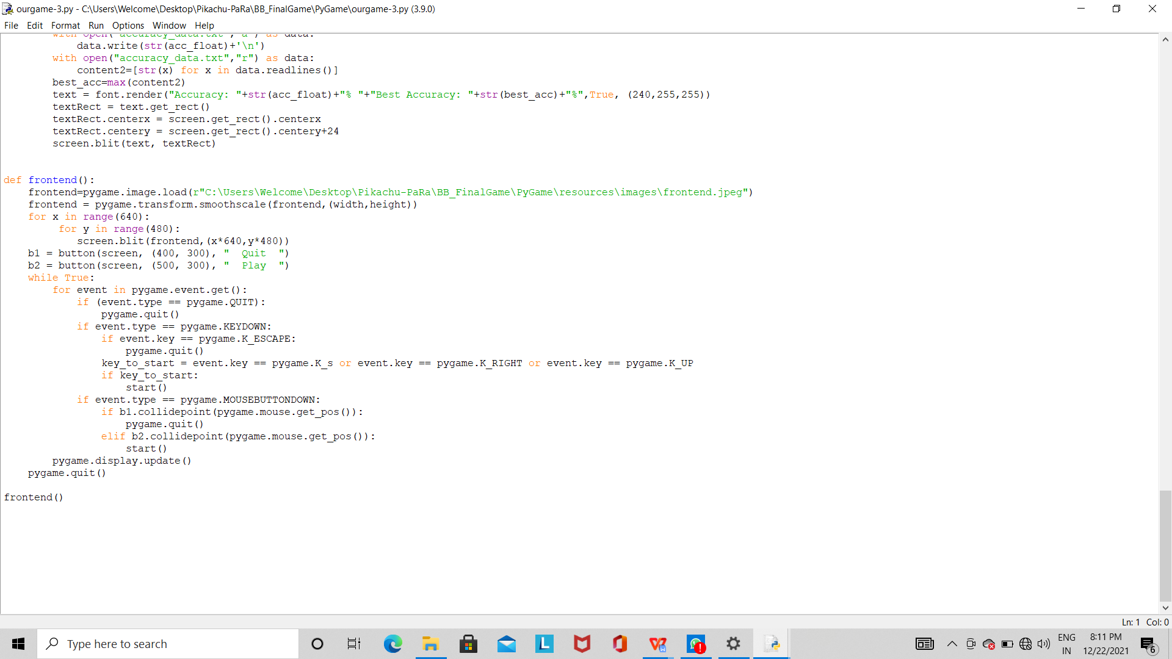

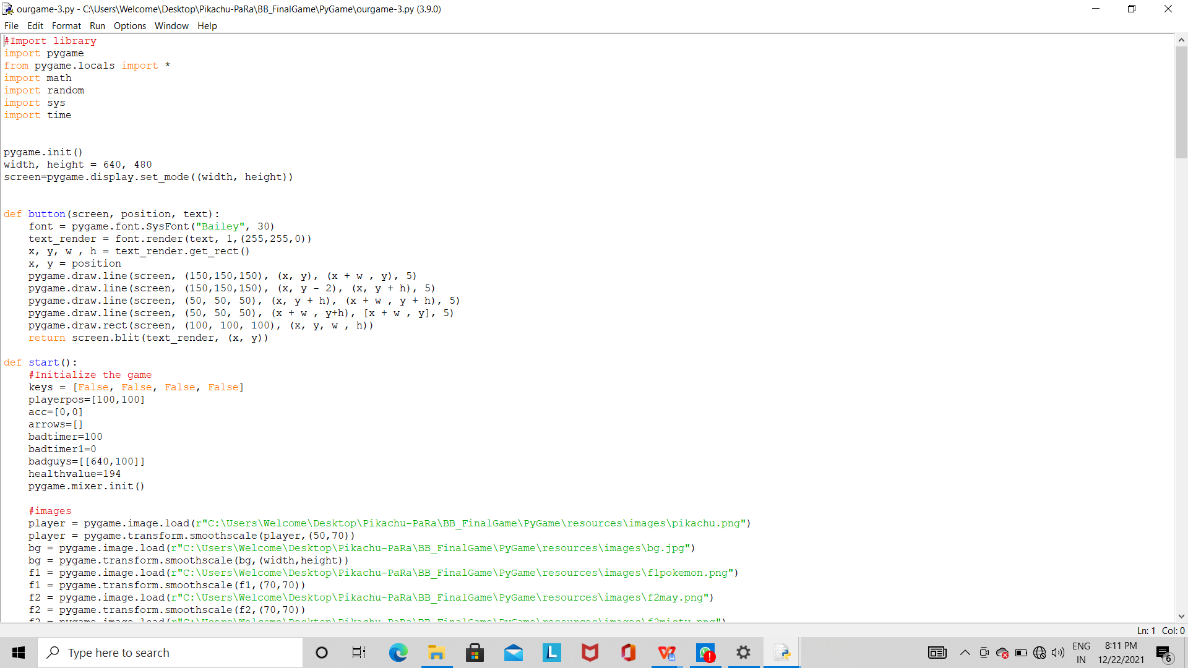

**Step 3: define start() to start the game when ‘start’ button is pressed .**

1. Initialize required variables and lists .
2. Import images and audios required for the game from (re)source file .

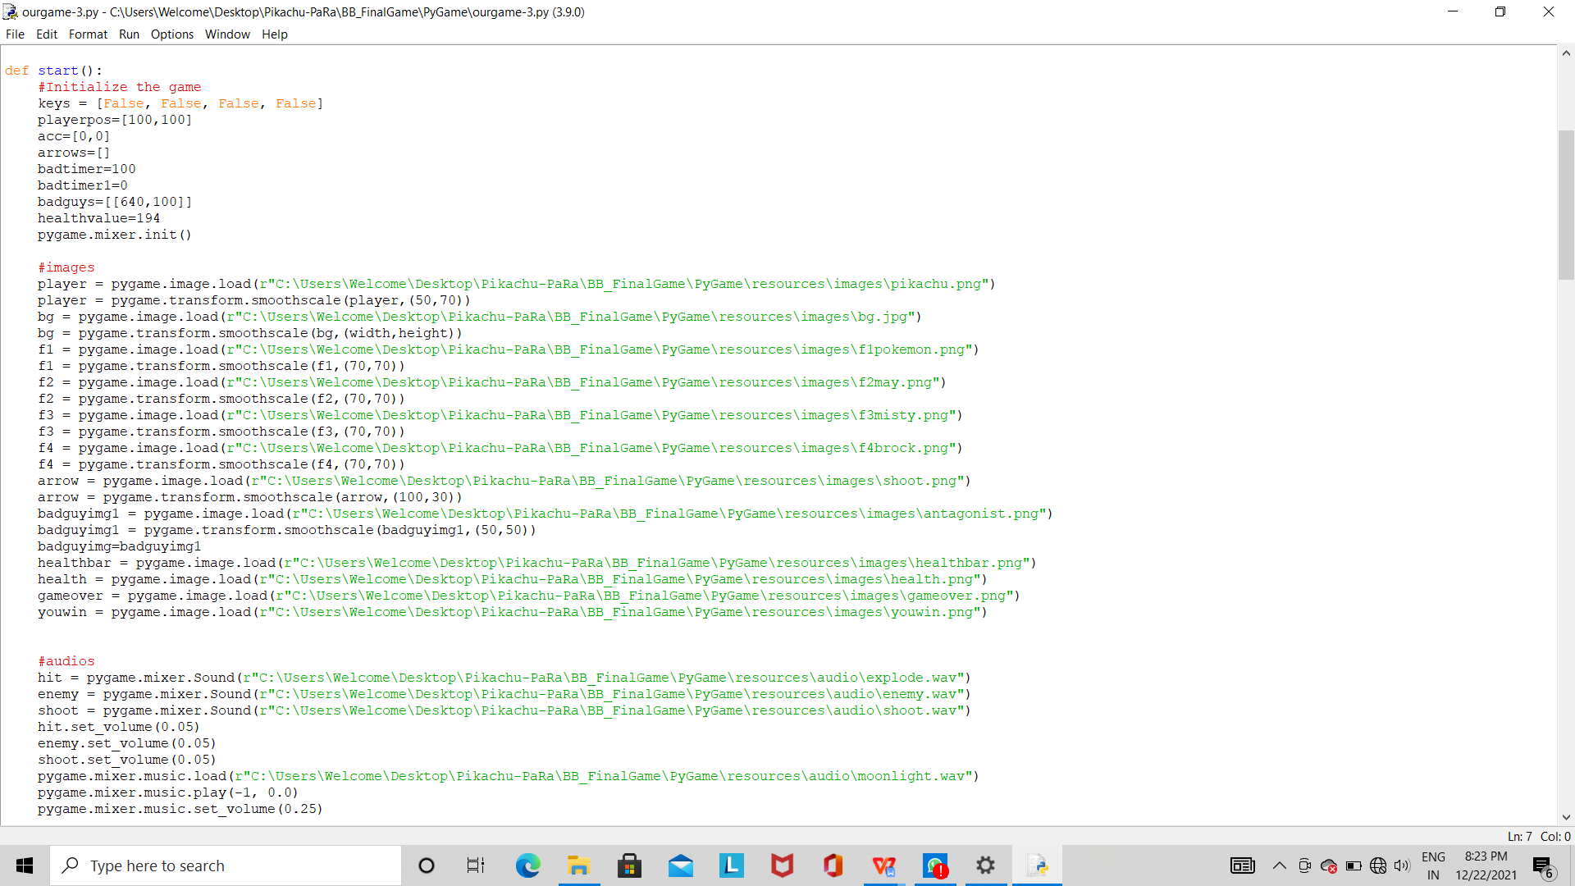

**Step 4 : create a loop which runs till game time or health is zero .**

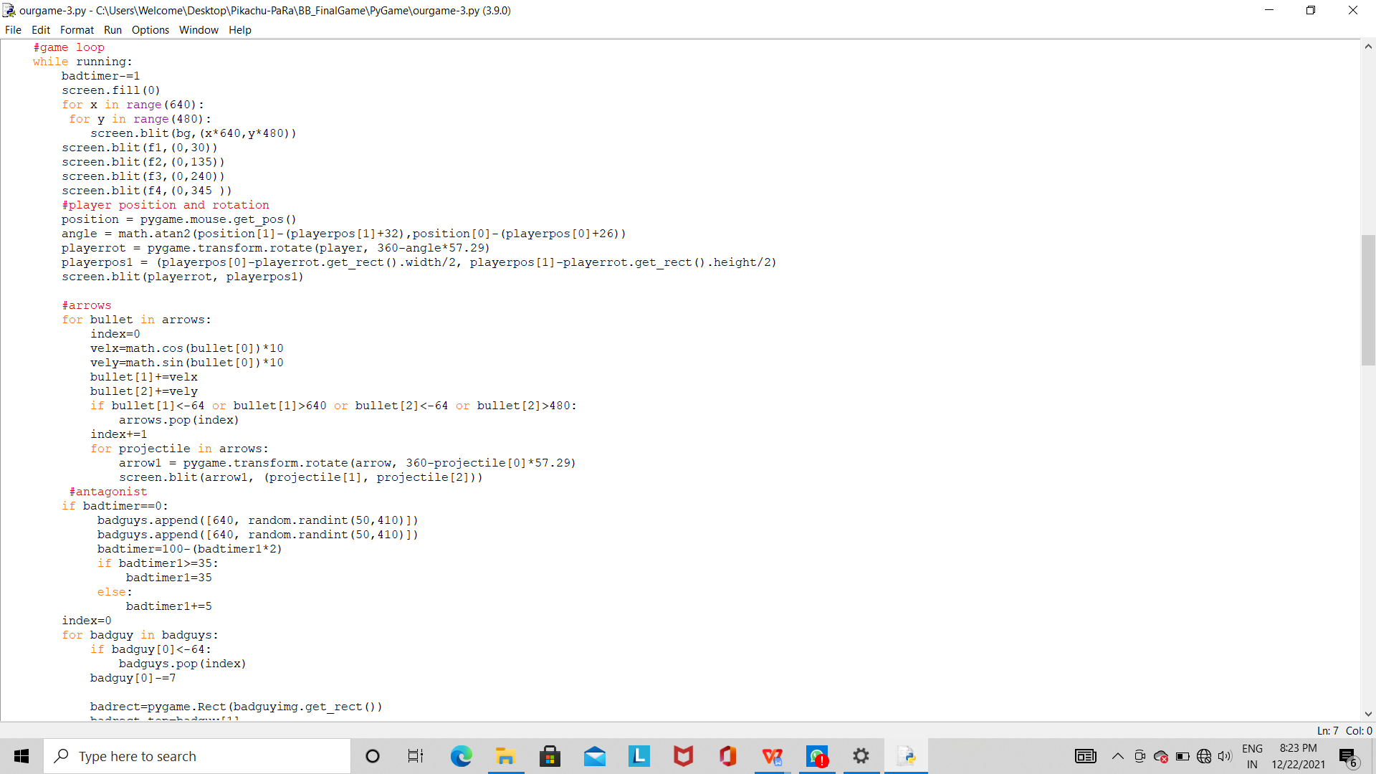

This loop contains further loops and if-else conditions for other functions / calculations .

‘random’ module is used to make antagonist come from right side of the screen in random positions .

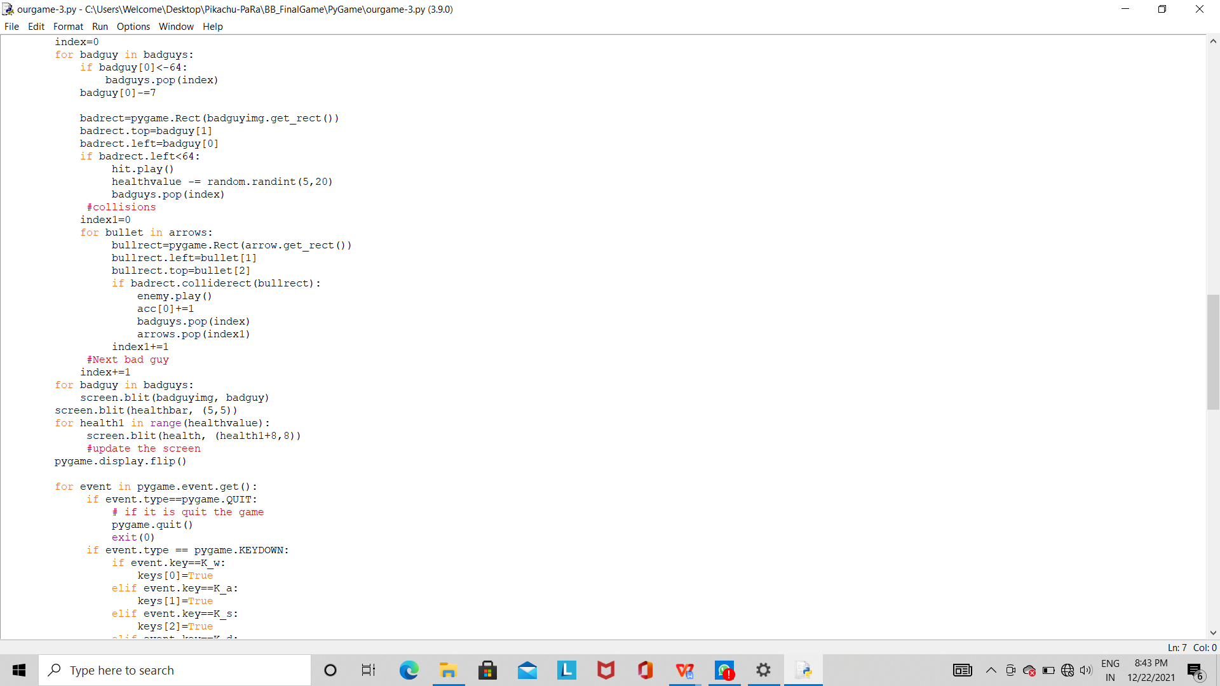

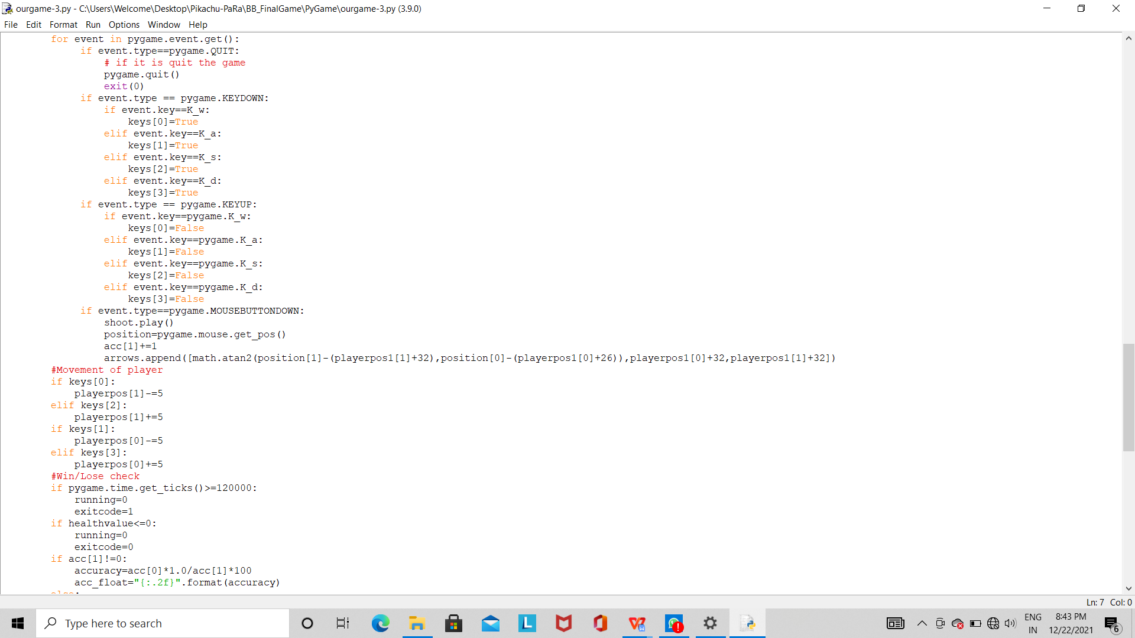

Key events are used for the movement of the player.

**Step 5 : if the player wins , accuracy rate is calculated and gets appended to the database . Then the best accuracy rate (maximum) from the database gets stored in an assigned variable and both gets displayed .**

**Else , accordingly a screen gets displayed with a message .**

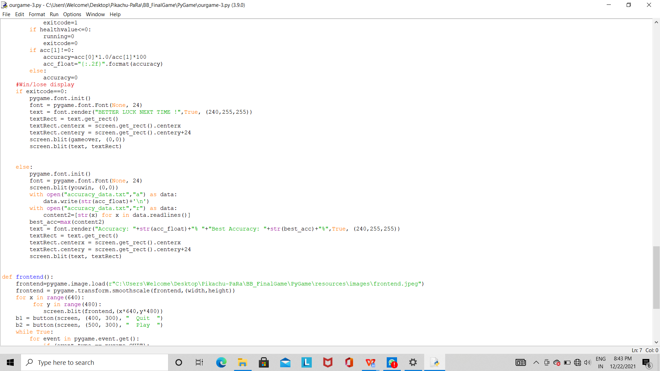

**4.3 FEASIBILITY STUDY**

A feasibility study is an assessment of the practicality of a proposed plan or project. A feasibility study analyzes the viability of a project to determine whether the project or venture is likely to succeed. The study is also designed to identify potential issues and problems that could arise from pursuing the project.

As part of the feasibility study, project managers must determine whether they have enough people, financial resources, and the appropriate technology. The study must also determine the return on investment, whether it's measured as a financial gain or a benefit to society, as in the case of a nonprofit.

**Benefits of feasibility study**

There are several benefits to feasibility studies, including helping project managers discern the pros and cons of undertaking a project before investing a significant amount of time and capital into it. Feasibility studies can also provide a company's management team with crucial information that could prevent them from entering into a risky business venture.

**4.4 RESULT**

The result can be either win or lose . If it is lose , a message gets displayed . If it is win , then accuracy data gets stored , the maximum one from the database gets returned and both gets displayed .

**4.5 SYSTEM DESIGN AND TESTING**

**4.5.1 System design**

The game is designed , implemented and working is tested . The system needs python idle of latest version for implementation . Installation of pygame library is necessary . Command prompt must ensure that the idle and pygame both are identified in the system to proceed with the development of game.

**4.5.2 Performance Testing**

The developed game performance starts with a pop up window which consists of two buttons . When start button is pressed , game must run . when quit button is pressed , the window must be closed . With in game time , whenever pikachu shoots the antagonist member , it must disappear at that point of time itself . If pikachu fails to do so , then the antagonist member reaches it's friends zone . when that happens , the health bar (of friends) must turn red ( little by little) . At the end of game time / within game time , if health bar is completely red , then the player lost the game . If not , that is , the health bar has some green within , then the player has won the game . If the player wins the game , accuracy rate of the player gets calculated , stored to the database and the database returns best accuracy rate . Finally , both the player's accuracy rate and best accuracy rate till time gets displayed .

**CHAPTER 5**

**CONCLUSION**

**5.1 CONCLUSION**

To conclude , we have developed a shooting game using python language with the help of pygame module .

**5.2 FUTURE ENHANCEMENT**

1. The options ' pause ' and ' resume ' can be brought to the game .

2. Individual accounts for every user can be created and datas like passwords and username need to be stored .

3. Scoreboard can be displayed at the end of the game listing the usernames with highest points .

4. Even some more levels can be developed for upgrading the game and making it more interesting for the users .

5. ‘Revive’ option can be given to user at a specific (randomly) time to revive their health bar and keep playing the game .

**APPENDIX A - SOFTWARE DESCRIPTION**

IDLE (Integrated Development and Learning Environment) is an integrated development environment for Python, which has been bundled with the default implementation of the language since 1.5.2b1. It is packaged as an optional part of the Python packaging with many Linux distributions. It is completely written in Python and the Tkinter GUI toolkit (wrapper functions for Tcl/Tk).

IDLE is intended to be a simple IDE and suitable for beginners, especially in an educational environment. To that end, it is cross-platform, and avoids feature clutter.

According to the included README, its main features are:

* Multi-window text editor with syntax highlighting, auto completion, smart indent and other.
* Python shell with syntax highlighting.
* Integrated debugger with stepping, persistent breakpoints, and call stack visibility.
* Author Guido van Rossum says IDLE stands for "Integrated Development and Learning Environment", and since Van Rossum named the language Python after the British comedy group Monty Python, the name IDLE was probably also chosen partly to honor Eric Idle, one of Monty Python's founding members.

**APPENDIX B - SAMPLE CODING**

**CODE :**



**APPENDIX C - OUTPUT**

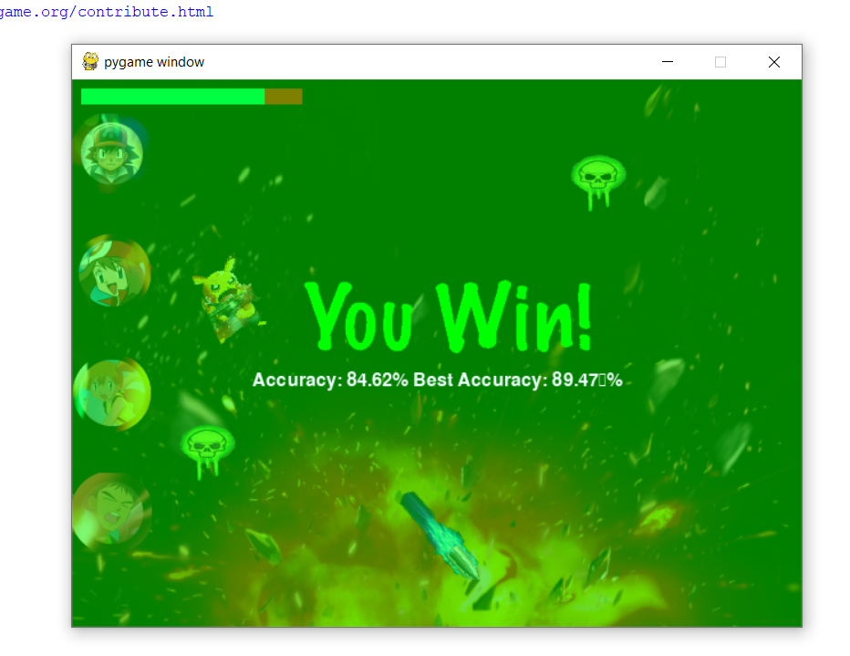

**(or)**

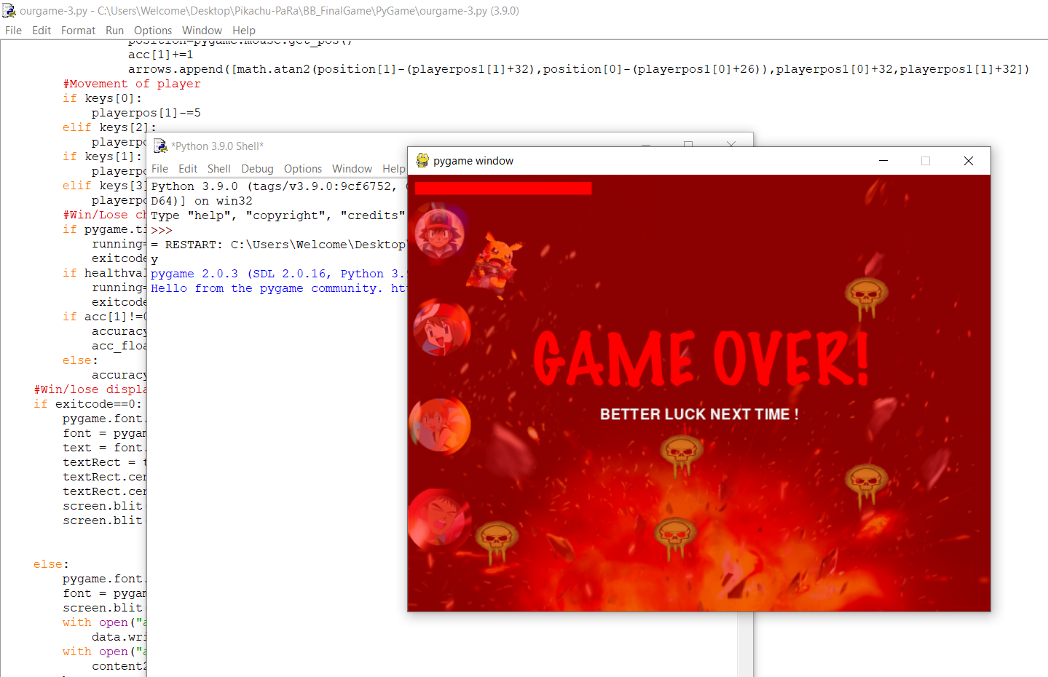

**REFERENCES**

1 . A Generative Programming Approach for Game Development ,Victor Travassos Sarinho & Antônio Lopes Apolinário , IEEE

2 . Board Games in the Computer Science Class to Improve Students’ Knowledge of the Python Programming Language , Dawid B. Jordaan , IEEE

3 . Game Design and Development Based on Logical Animation Platform , Chen Mao , Zhang Yi , Ouyang JianGang & Hu Guo-tao, IEEE